Negative Numbers-Questions
Key Stage 3: 2003 Paper 1 Level 3
1.
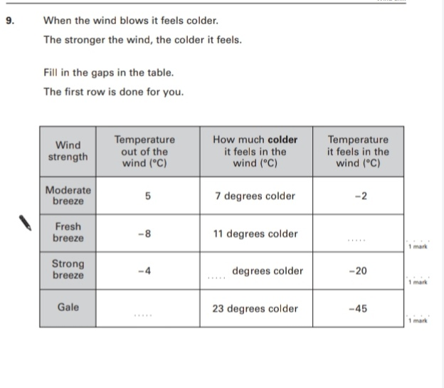
Key Stage 3: 2003 Paper 1 Level 4_6
2.
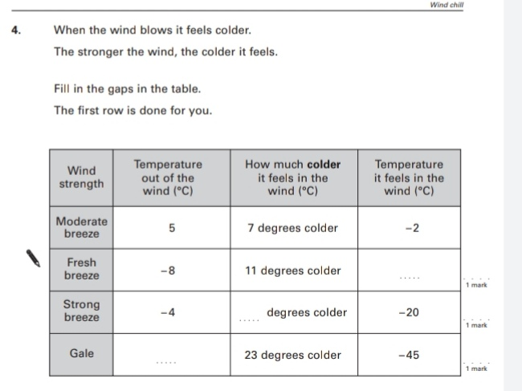
Key Stage 3: 2005 Paper 1 Level 3-5
3.
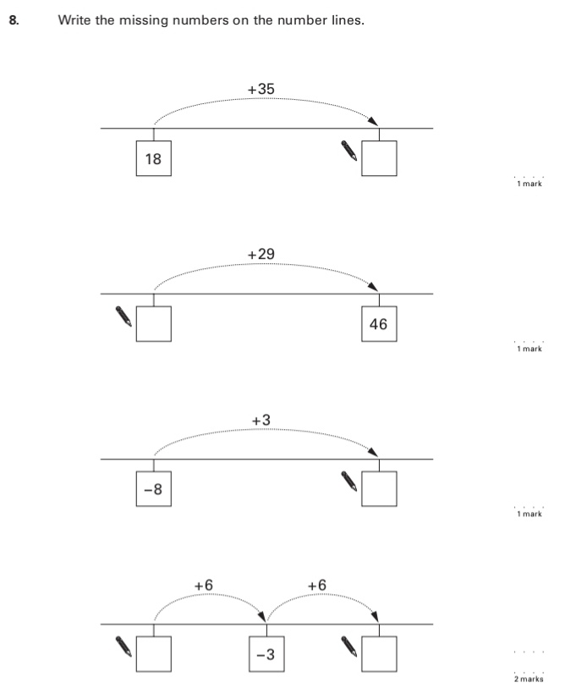
Key Stage 3: 2005 Paper 1 Level 4-6
4.
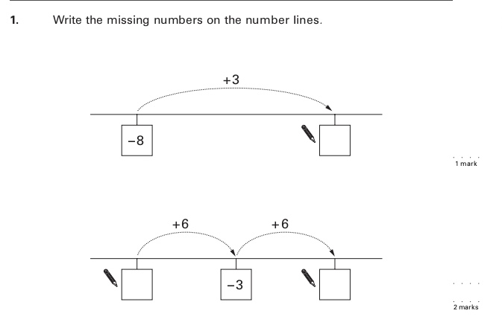
Key Stage 3: 2006 Paper 1 Level 3-5
5.
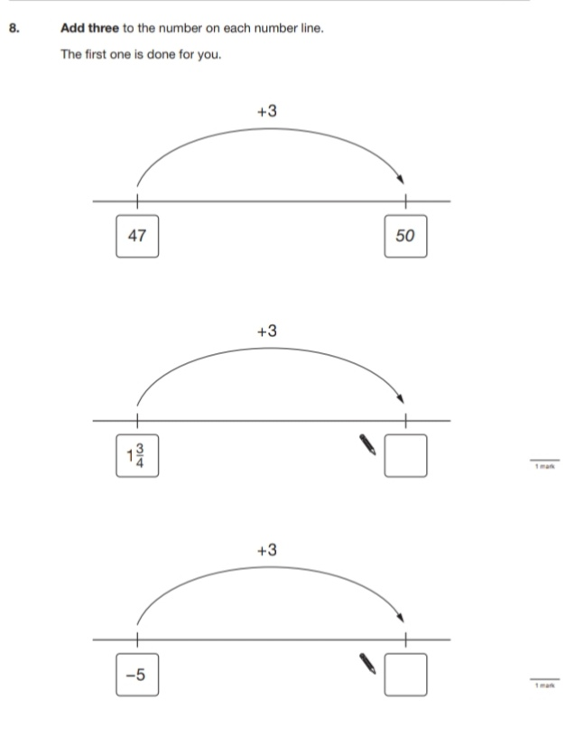
Key Stage 3: 2006 Paper 1 Level 4-6
6.
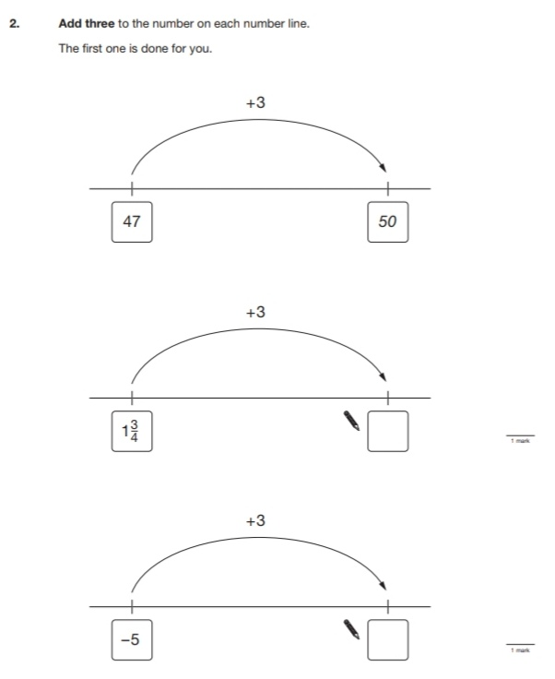
Key Stage 3: 2007 Paper 1 Level 3-5
7.
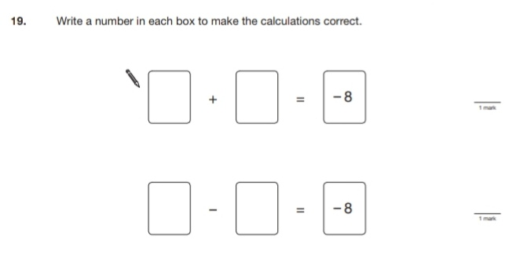
Key Stage 3: 2007 Paper 1 Level 4-6
8.
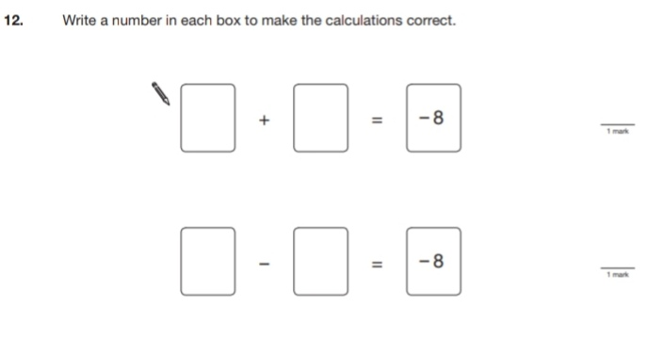
Key Stage 3: 2008 Paper 1 Level 3-5
9.
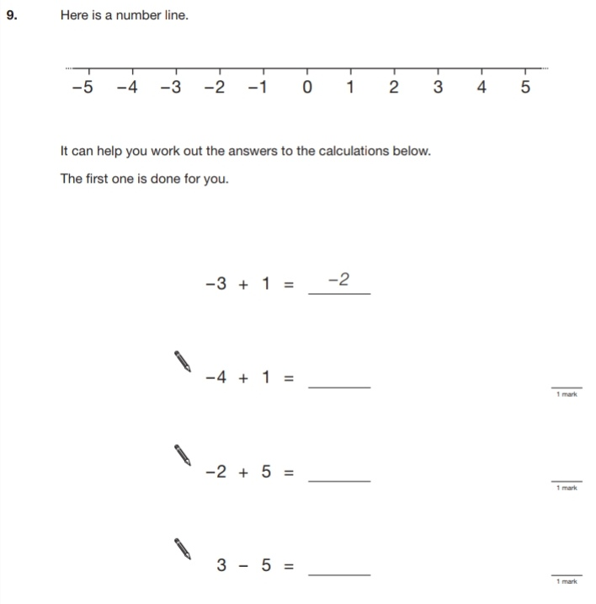
Key Stage 3: 2008 Paper 1 Level 4-6
10.
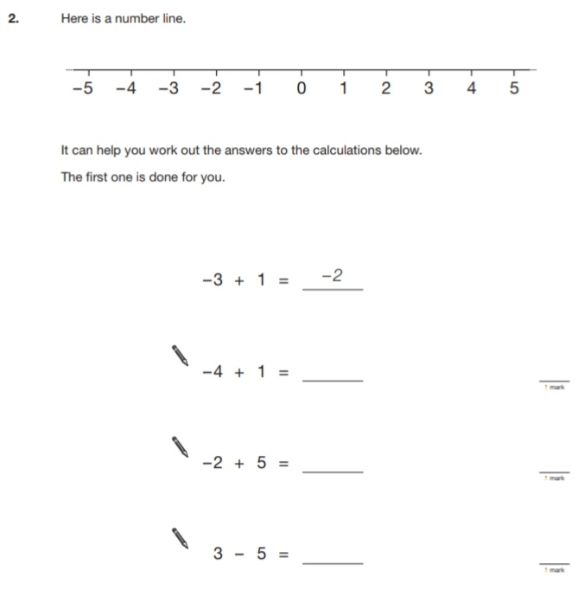
Key Stage 3: 2009 Paper 1 Level 3-5
11.
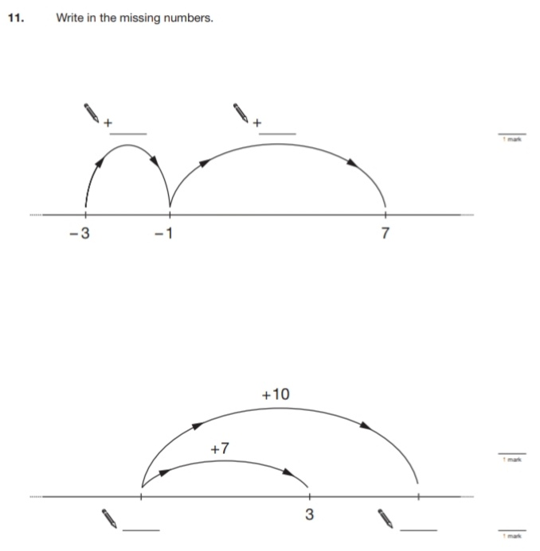
Key Stage 3: 2009 Paper 1 Level 4-6
12.
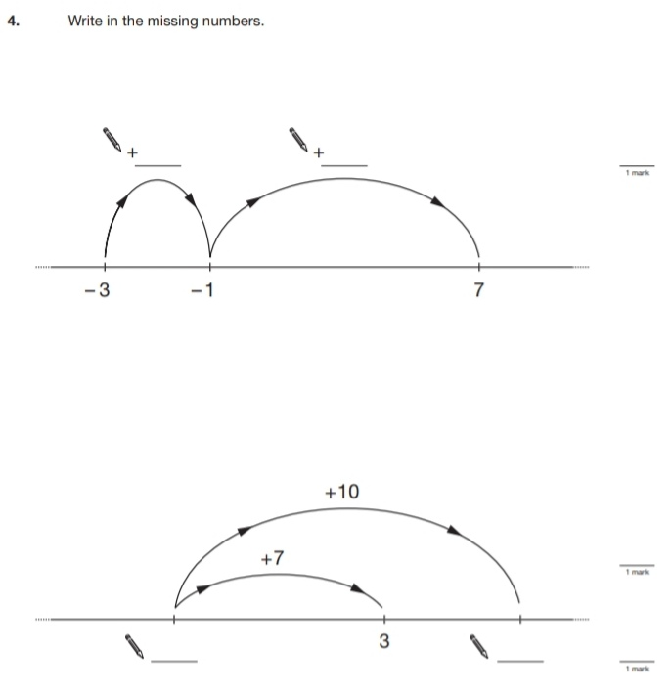
Key Stage 3: 2010 Paper 1 Level 3-5
13.
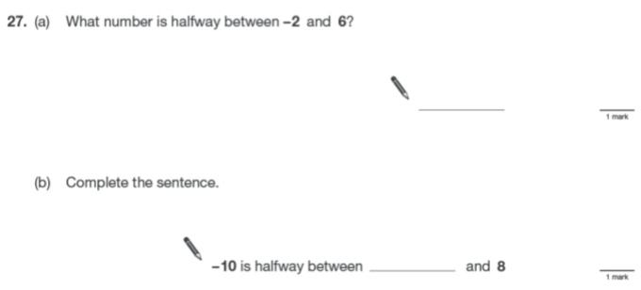
Key Stage 3: 2010 Paper 1 Level 4-6
14.
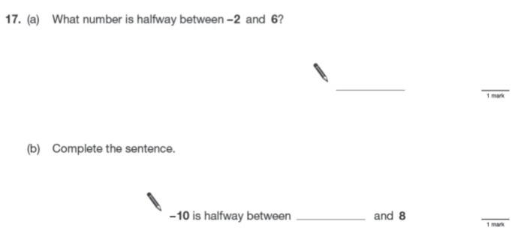
Key Stage 3: 2011 Paper 1 Level 4-6
15.
